Homework - First Progress Report on Project 1
Niño Aloysius V. De Mesa
Grouped with Peter Estacio and Joshnare Ong
ENGG 123.01 – J1
August 18, 2026

For project 1, Peter Estacio, Joshnare Ong and I have decided to become groupmates. During our first week of doing the project, several key specifications of the code has been initially implemented. The code is now able to process user inputs and read an 8-character hex string and decode this into the 32-bit RISC-V Instructions. This is done by extracting all the details in the hex string such as the opcode, funct3, funct7, rd, rs1, rs2, format, and instruction. Additionally, a working user input validation was also implemented to ensure that users may only input 8-character length hex strings. Finally, appropriate outputs are produced by providing all the decoded information from the hex string while also allowing the user to exit program by typing “quit”. For future progress, the group would focus more on validating the program while also implementing a case provided by the specification, mainly about instructions that cannot be fully decoded. Figure 1 shows the program being executed with a sample 8-character hex string.

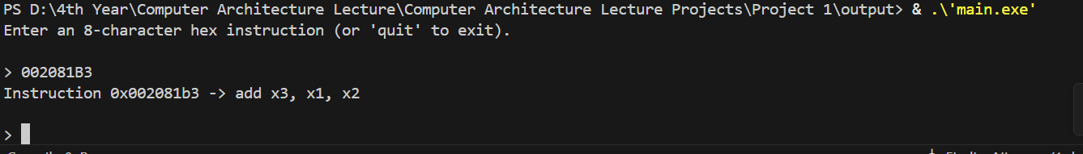
Figure 1: Execution of the Program showing the input and the appropriate decoded output

